December 12, 2020

Notice to Providers: New Population Health Tool Available in the CountyCare Provider Portal

Dear CountyCare Provider,

CountyCare has partnered with Vital Data Technology (VDT) to provide a new population health tool that can be used to identify patient care gaps for your panel. Affinitē ProviderLink is now live within the CountyCare Provider Portal. ProviderLink allows you to view and export HEDIS measure performance, gaps in care patient lists, and patient claims history. The goal is to provide you with more accessible, timely, and actionable HEDIS measure reporting for closing gaps in care.

Below are instructions on how to access ProviderLink and who to contact if you require support.

Accessing Provider Link via the Provider Portal

Log into the portal:

Click on “ProviderLink HEDIS”:

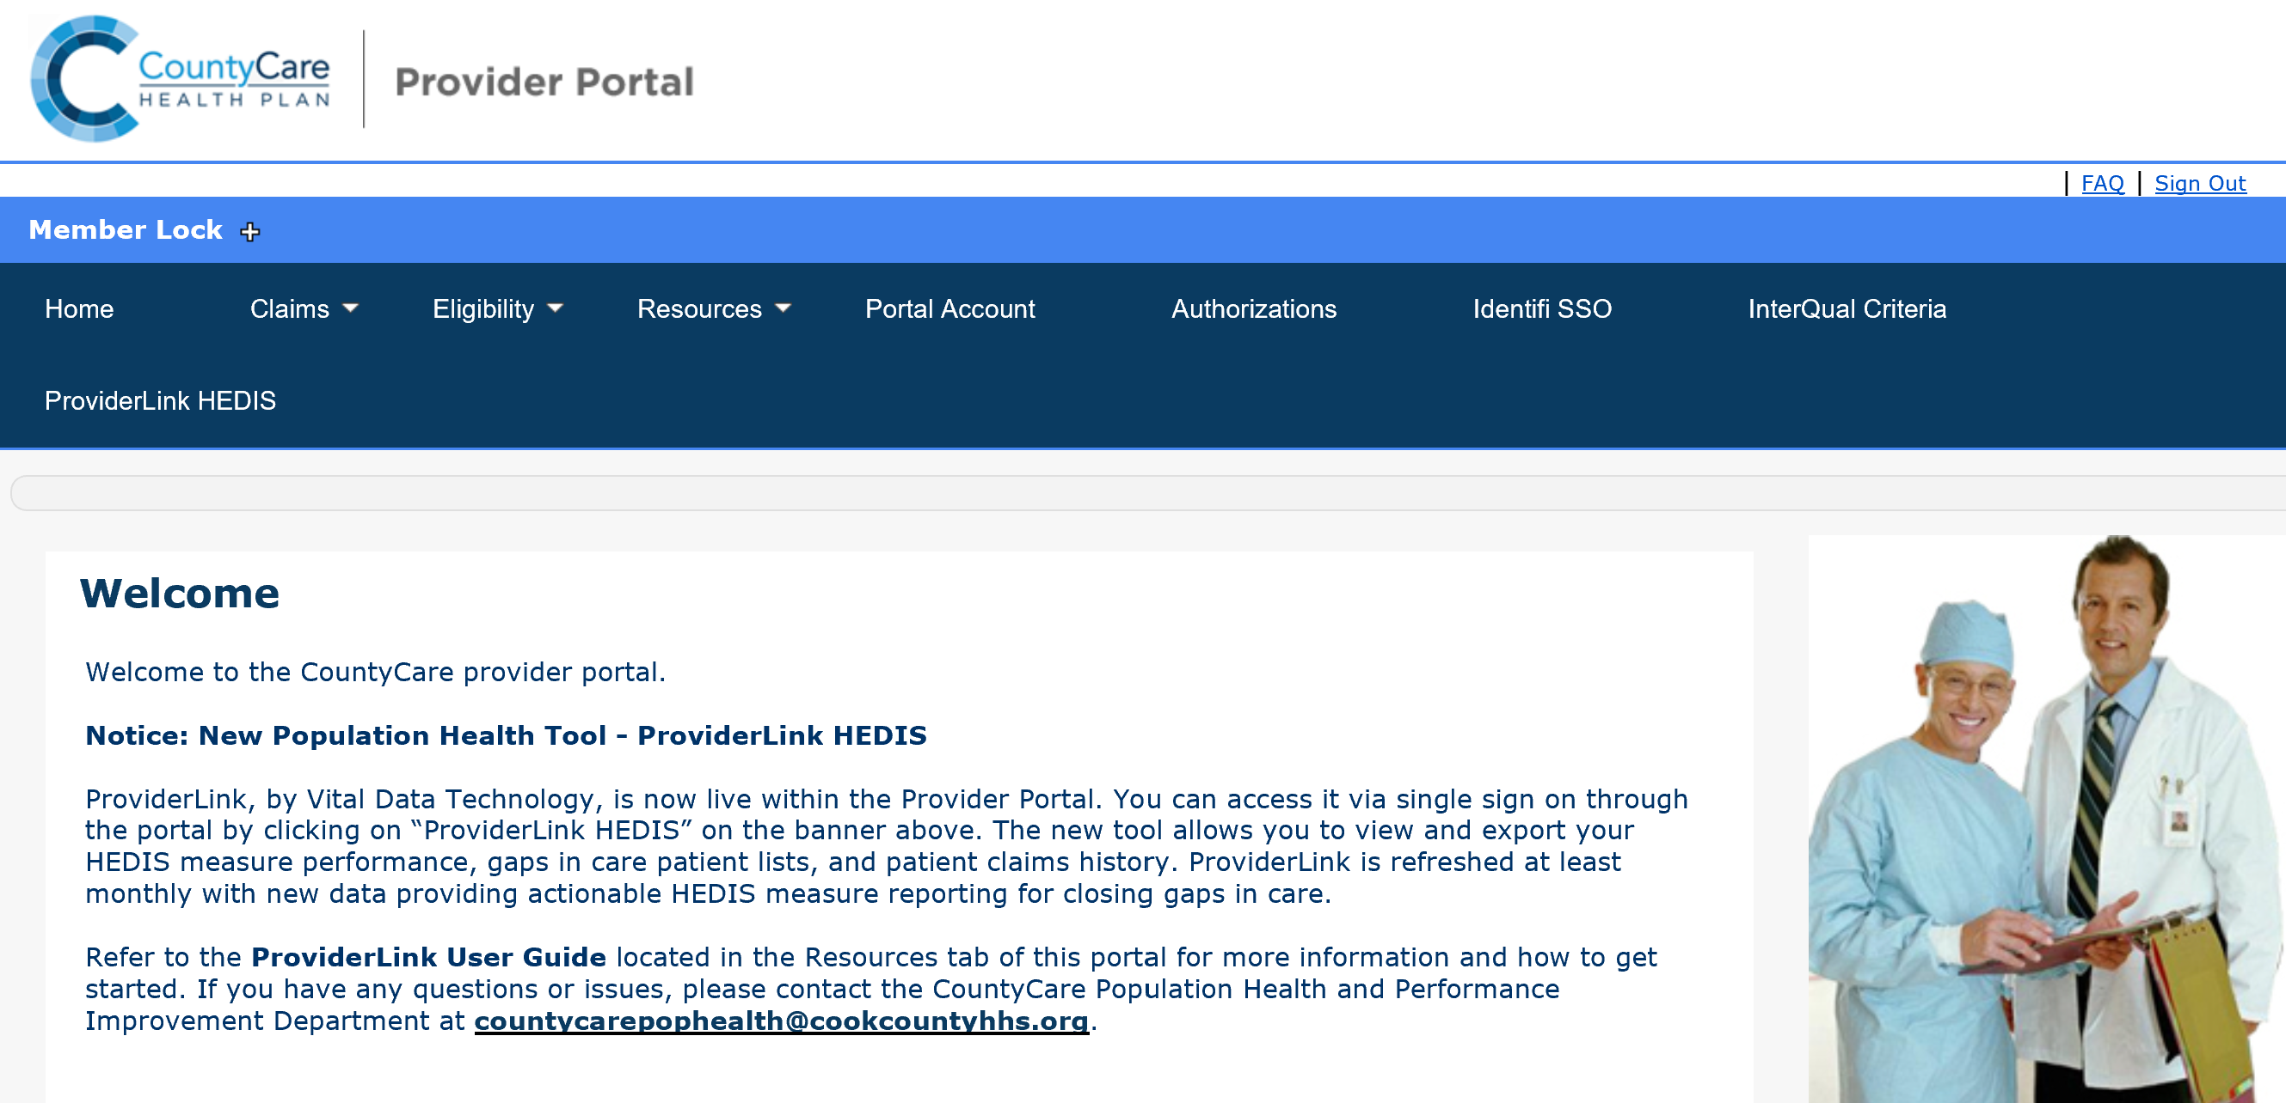
Contact Us

If you have any questions or would like additional information, please contact the CountyCare Population Health and Performance Improvement Department at countycarepophealth@cookcountyhhs.org .

Thank you again for your commitment to CountyCare. We value you as a partner and appreciate your support in our efforts to continue to provide quality care to our members.

Sincerely,
The CountyCare Team

Attachment: Quick Reference Guide

