January 2023

Emergency Meals Program Reinstated

We are excited to share that CountyCare’s Emergency Meals Program has now been reinstated with a new partner, Foodsmart. This is only the start of a more robust Nutrition Program that will be launched in early 2023. We have prioritized the emergency meals program to ensure our members in need of immediate assistance are able to receive nutritious meals. Like the previous program, CountyCare members who are experiencing food insecurity are eligible for this one-time emergency food assistance service to receive 14 meals (two meals per day for seven days).
Instructions for submitting an emergency meal order for CountyCare members are detailed below
- Member identified as food insecure with emergent need
- Complete the Excel referral form
  - Fill out all fields highlighted in pink. If you are speaking directly with the member, ask them for their most up to date information and be prepared to confirm if they have any allergies or dietary restrictions
  - In Section B, all dietary restrictions are set to “no dietary restrictions” by default so please ensure any restrictions are noted
- Save the Document as “CountyCare Emergency Meal Referral – MM-DD-YYYY” (EG: 01-03-23) in a secure storage location on your local device”
- Attach the document to an encrypted email addressed to foodscripts@foodsmart.com
  - The form MUST be sent as an encrypted email. Instructions for how to submit an encrypted email for Cook County Health employees are below. If you are from an external organization, you will need to follow your organization’s instructions for sending encrypted messages when submitting an Emergency Meals Referral Form
- For Cook County Health: After attaching the completed and renamed form to your email message, enter the following information into the subject line to encrypt the email:
  - SECURELOCK CountyCare Emergency Meal Referral - Date (EG: 1/3/23)
    - Example of subject line using 1-3-23 as the date: SECURELOCK CountyCare Emergency Meal Referral – 1-3-23
- Let the member know that they will be receiving a call, text, and email to confirm their address and allergy information and that they can expect 14 meals (two meals a day for seven days) to be delivered within 72 hours
  - Foodsmart will attempt to contact the member three times through phone calls, emails, and text messages. If they are unable to connect with the member, an allergen-free meal box will be sent to the member after 72 hours have elapsed
Once the email is submitted, you have completed the process. Foodsmart representatives will reach out to you directly if there is an issue with your submission or if they have additional questions about the member.

Below is a summarized workflow highlighting the referral process.

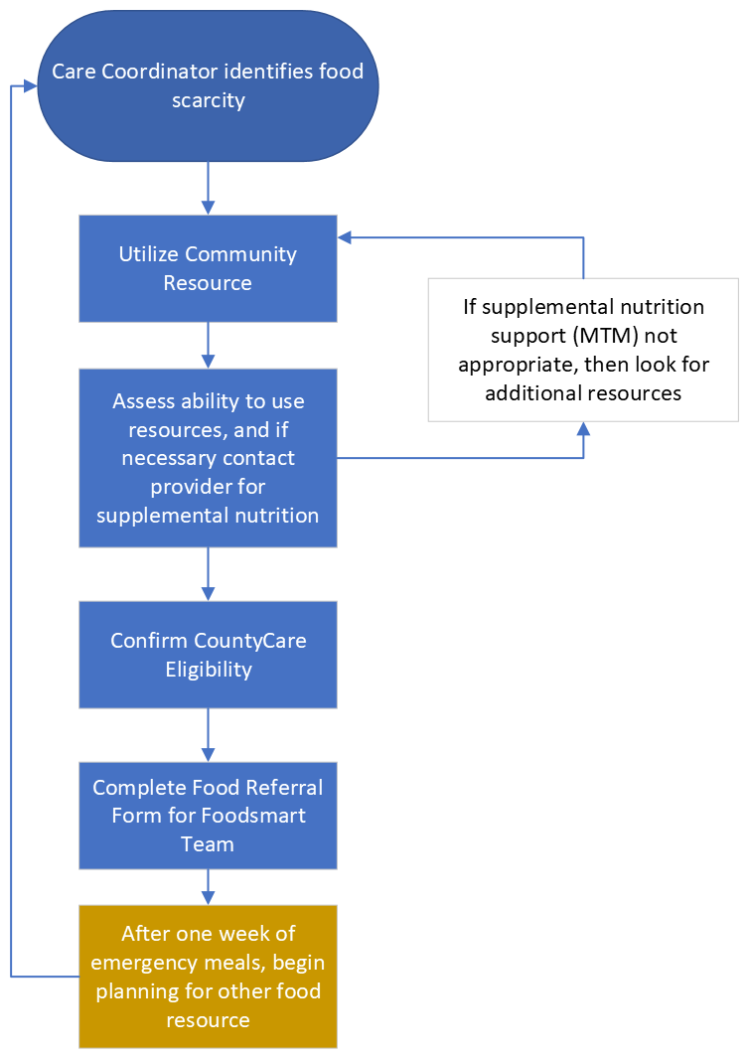
Please reach out to Andrew Gillen (andrew.gillen@cookcountyhealth.org) directly if you have questions or feedback regarding the submission process.

