You can view your health information through an app. Learn how.
Accessing your health data
CountyCare is committed to using data to improve your health and health care. We have made it easier for you to access your health data. Having access to your data can help you make more informed decisions about your health care.
‌
Why should I access my health data?
‌Some health care choices are easy, like getting a cast if you break your arm. Others are more complex. By viewing your health information through an app, you can:
- Gain control over your health data
- Make it easy to share your health data with doctors, caregivers, or anyone you choose
- Get help managing and improving your health through several apps and other computer-based services

‌How do I access my health data?
‌The process is like loading other apps to your device from an app store such as the Apple App Store, Microsoft Store, Google Play, or others.
‌
To access your health data:
- Find the app you want to use in this linked list of connected applications.
- Download the app.
- Follow the sign-up process.
- Use the app's menus and prompts to connect the app to CountyCare.
- Provide your consent to share your health data with the app.
- Verify the process for contacting the app developers for any issues that may arise.

Is my health data private and secure?
As with any digital transaction, there is some risk. CountyCare takes the security of your health data seriously. Your data will never be shared without your consent. CountyCare guards your data by using authentication codes. This helps confirm that only you can access and share your data. However, CountyCare is not responsible for the security of your data once it is shared with a third-party app. Always read the privacy and security policies for any app you share your data with. This will help you know how your data will be used. Be sure to guard your devices from threats like theft, phishing, and hacking. Keep your device's security settings current. Only choose apps with clear privacy and security policies. You can choose whether to access your health data via an app. You can change your mind at any time.

CountyCare is subject to healthcare privacy and data security laws. This includes HIPAA (the Health Insurance Portability and Accountability Act). Generally, third-party apps are not subject to HIPAA laws. These apps are consumer products governed by the Federal Trade Commission.

Why is my health plan allowing apps to connect to my health data?
CountyCare cares about your health and helping you manage your own health. This new way to help you access your data is a federal government requirement. The federal government, the healthcare industry, and CountyCare are working toward several goals:
‌
- Patient Access - ensuring patients are well-informed about their own health and health care
- Interoperability - making it easier to share data between patients, doctors, caregivers, and other people and organizations working to improve your health

‌Some of these goals and rules are covered by a federal law, the 21st Century Cures Act. This law requires and allows CountyCare to make your health data easier for you to access.
‌
What is the sign-up process like?
‌The first time you choose to share your data with an app, you must set up an account. You will need your name, date of birth, plan member ID, zip code, and a valid email address. Your app will walk you through a process like this:

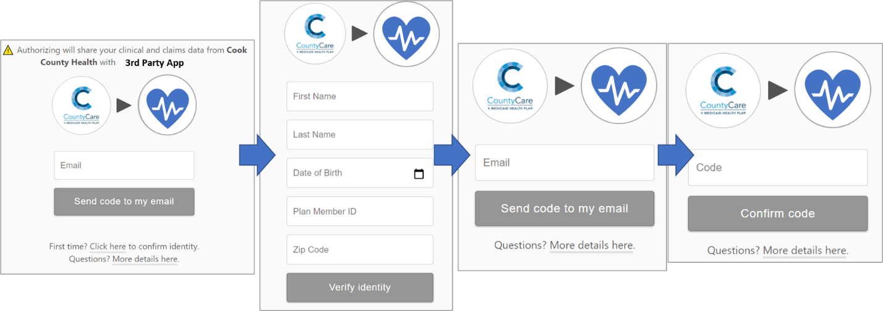

How do I allow an app to see my health plan data?
To give access to your data to an app, you must create an account using your first name, last name, date of birth, member plan ID, zip code, and a unique email address.

Will I have to create a new account for each app I use?
No. Once you have allowed one app to see CountyCare data, you only have to sign-in using your email address and security code to let another app see your data.

What email is used to allow an app to see my health plan data?
You must use the email address that you first used to allow access to your data. A code will be sent to that email, and you will enter it into the app. If you do not recall your email address, please contact CountyCare health plan via phone at 312-864-8200.

Are the name fields case sensitive?
No.

How can I find my Member ID?
It is the member ID on the member ID card given to you by CountyCare. If you do not have this card, or if the number you gave caused an error, please contact CountyCare at 312-864-8200.

I have signed up for an app, but I don't see any data.
Contact the app developer via the information that they have provided in the app. The app developer will try to fix the issue. If they cannot fix it, they will contact 1UpHealth, a partner of CountyCare, to work together until the issue is fixed. The app developer will contact you once it is fixed.

I have signed up for an app, but some data is missing.
Contact the app developer via the information that they have provided in the app. The app developer will try to fix the issue. If they cannot fix it, they will work with 1upHealth, a partner of CountyCare, to work together until the issue is fixed. The app developer will contact you once it is fixed.

Some data considered “sensitive” may not be shared with the third-party app based on the preferences selected while creating an account.

Where can I find a list of apps that have been approved by my health plan?
Click here to find a list of apps that have been deemed as qualified and secure. Apps are added on an ongoing basis and will be kept up-to-date on this website.

I would like to keep my data related to mental health, substance use, or reproductive health private. How can I keep this data from being shared?
During the sign-up process for a third-party app, you will have the opportunity to select which data marked as “sensitive” to share. By leaving the box next to one of the listed data types unchecked, you can prevent it from being shared with the application.

Why am I being asked to select which “sensitive” data elements should be released to a third-party app?
Some data, such as mental health, substance use, or reproductive health data is deemed “sensitive” in Illinois. As such, additional security steps must be taken before they can be released. By leaving the box next to one of the listed data types unchecked, you can prevent it from being shared with the application.

A message stating that I am not able to share my data appeared. Why is that?
By law, children under 13 years of age cannot share their data without help from a parent or guardian. If you are over 13 years old and received this error message, please contact CountyCare via phone at 312-864-8200.

What do I do if I think that an application has broken their privacy policy?
If you think an app that you've shared your data with is breaking their stated privacy policy, alert the Federal Trade Commission by going to ReportFraud.ftc.gov or calling 877-382-4357.

If you believe the privacy of your health care data has been violated, alert the Department of Health and Human Services Office of Civil Rights at www.hhs.gov/ocr/complaints.

